Matej Popovski

STAT 436

Prompt

Determine whether the following statements about ggplot2 are TRUE or FALSE. For at least one statement, provide an explanation based on the Penguins dataset demo.

1. TRUE FALSE To use a custom color palette in a ggplot2 scatterplot, we can add a scale_color_manual layer.

TRUE - To use a custom color palette in a ggplot2 scatterplot, we can add a scale_color_manual layer.

Explanation: In ggplot2, you can define custom colors for specific groups in a scatterplot by using scale_color_manual(). For example, using the Penguins dataset:

ggplot(penguins, aes(x = bill_length_mm, y = bill_depth_mm, color = species)) +

geom_point() +

scale_color_manual(values = c("Adelie" = "red", "Chinstrap" = "blue", "Gentoo" = "green"))

1. TRUE FALSE A geom_boxplot layer can be used to simultaneously visualize a continuous variable against many levels of a categorical variable.

TRUE - A geom_boxplot layer can be used to simultaneously visualize a continuous variable against many levels of a categorical variable.

Explanation: geom_boxplot is commonly used for this purpose. For instance, using the Penguins dataset to visualize flipper length (continuous) against species (categorical):

ggplot(penguins, aes(x = species, y = flipper_length_mm)) +

geom_boxplot()

1. TRUE FALSE A plot like the one shown below can be made using a geom_area layer.

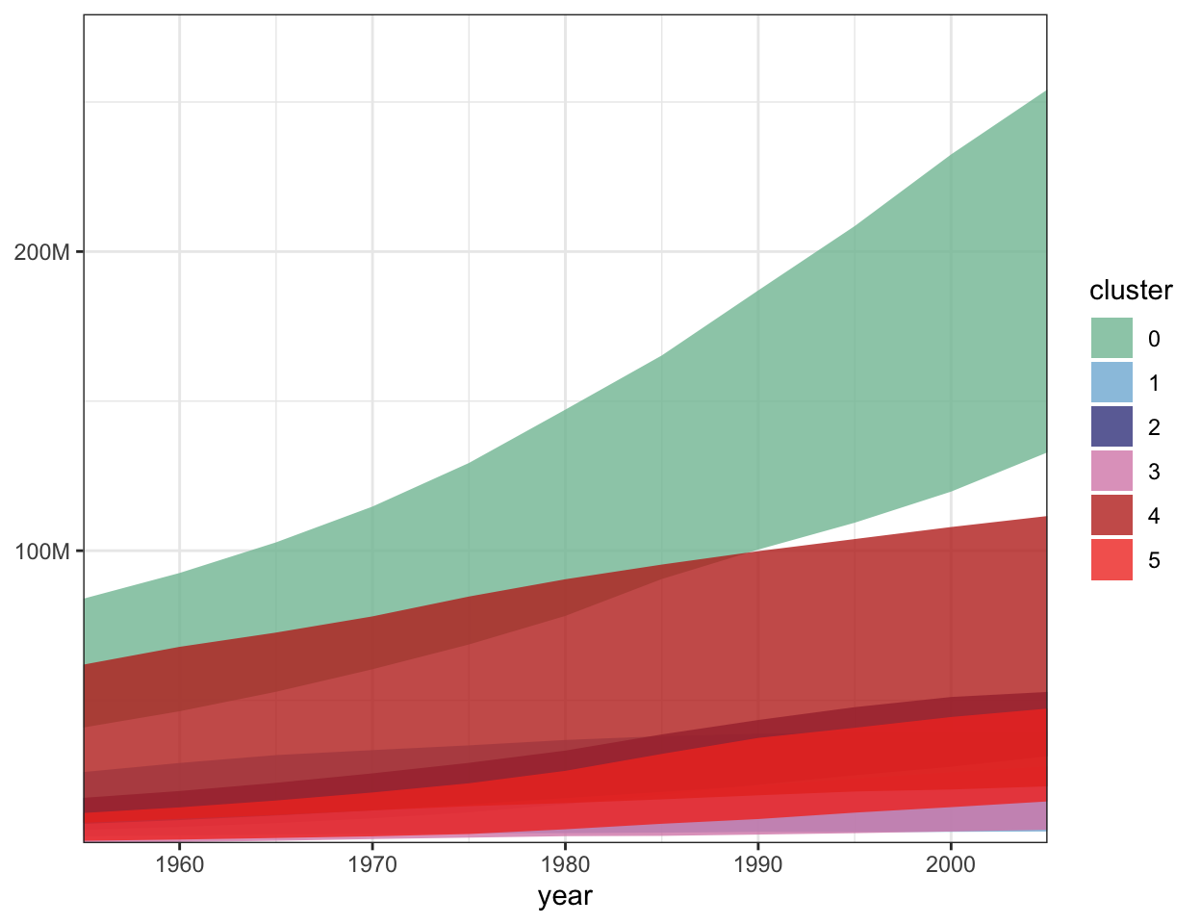

TRUE - A plot like the one shown can indeed be made using a geom_area() layer in ggplot2.

Explanation:

The geom_area() function in ggplot2 is specifically designed to create area charts, where the y-values are filled between the x-axis and a line representing the data. Stacking can be applied by mapping a categorical variable (such as cluster) to fill.

1. TRUE FALSE The aes() function maps values stored in the columns of a dataset into properties of graphical marks.

TRUE

Explanation:

The aes() function in ggplot2 is used to map variables (columns) from a dataset to visual properties (aesthetics) of graphical marks, such as position, color, size, shape, etc. These mappings determine how the data is represented in the plot.

Responses

1. TRUE - slide 18 b) TRUE - slide 16 c) TRUE - slide 11 d) TRUE - slides: all💀
2. TRUE b) TRUE c) TRUE d) TRUE
3. TRUE (prof changed colors for penguin species) b) TRUE c) TRUE d) TRUE

TRUE b) TRUE c) TRUE d) TRUE - live lecture demo example, where the prof applied the bill_depth and bill_length across all layers of graphs on the figures (across geom_smooth, geom_point, etc.)

1. TRUE b) TRUE c) TRUE d) TRUE: Using color to show a third property in the dataset
2. TRUE b)TRUE c) TRUE d) TRUE
3. TRUE b) TRUE c) TRUE d) TRUE
4. True b) True c) True d) True
5. True b) True c) True d) True
6. True
7. True b) True c) True d) True
8. True b) True c) True d) True
9. TRUE b) TRUE c) TRUE d) TRUE

For a if we are writing this ggplot(penguins, aes(x = bill_length_mm, y = bill_depth_mm, color = species)) + geom_point() + scale_color_manual(values = c("Adelie" = "blue", "Gentoo" = "red", "Chinstrap" = "green")). Here scale_color_manual() overrides the default palette and applies the custom colors for each penguin species.

1. True b)TRUE c)True d(True
2. True b) True c)True d)True
3. TRUE b) TRUE c) TRUE d) TRUE